Lab Assignment 2

Kartikeya Gokhale (201701175) Smit Shah (201701009)

January 26th, 2019

QUESTION – 1

Computationally analyze the motion of freely falling body using Euler’s method as discussed during the lecture. Consider realistic initial conditions (height, initial velocity etc.) Compare your result with analytical solution and study the effect of discretization (timestep) on computational result.

Plot the results showing the velocity of the body and the distance travelled by it at different instant of time.

The above problem is not realistic from Earth’s viewpoint, use the code to analyze the motion of falling body on the moon (there is hardly any atmosphere, so in reality also we can neglect the effect of atmosphere, however initial conditions will be different).

ASSUMPTIONS:

1. The gravitational force remains constant all heights.
2. Effect of atmosphere and hence the drag is neglected.

INITIALIZATION:

1. g_earth is the acceleration caused by gravity, g = 9.8m/s2
2. g_moon is the acceleration caused on moon g_moon = 1.63 m/s2
3. max_t is the time duration
4. initial_height is the height the freely falling body is thrown.
5. v is the velocity of the body
6. x is the position of the body

COMPUTATIONAL MODEL:

position(i+1) = position(i) + dt*velocity(i)

velocity(i+1) = velocity(i) + dt*g_moon

ANALYTICAL SOLUTION:

Equations:

RESULTS:

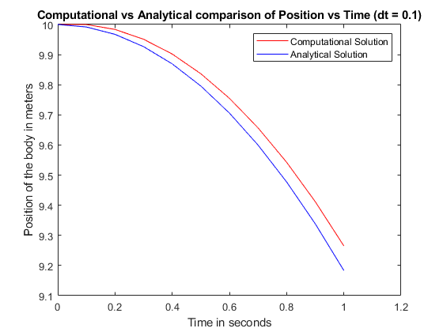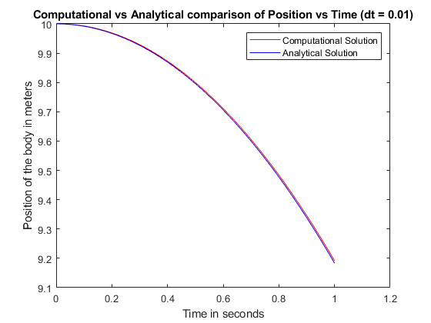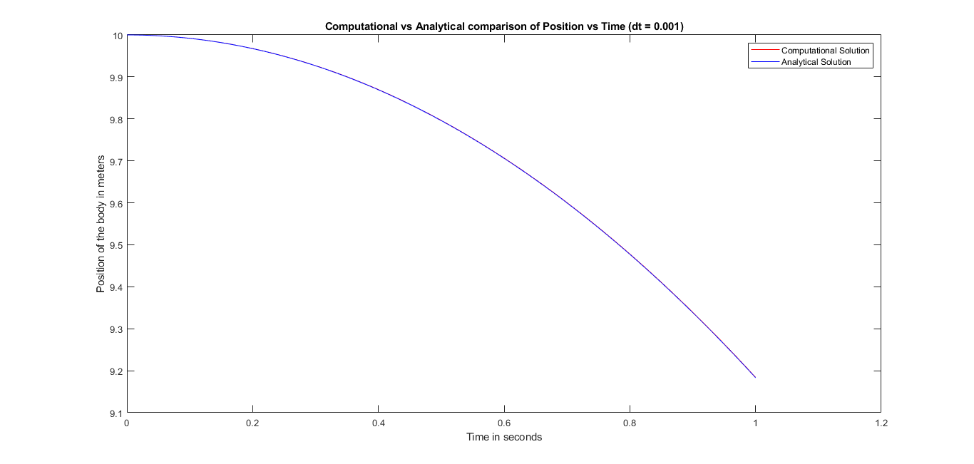

OBERSARVATIONS:

Decreasing the value of dt decreases and the analytical and computational models converge.

QUESTION – 2

Write down the equation for position of an object moving horizontally with a constant velocity “v”.

Assume v=50 m/s, use the Euler method (finite difference) to solve the equation as a function of time.

• Compare your computational result with the exact solution.

• Compare the result for different values of the time-step.

ASSUMPTIONS:

1. The surface under consideration is frictionless.
2. The drag force due to air is neglected.

INITIALIZATION:

1. max_t is the time duration.
2. Initial velocity v = 50 m/s.
3. x is the position
4. x_analytical is the analytical solution of the problem.

COMPUTATIONAL MODEL:

ANALYTICAL SOLUTION:

RESULTS:

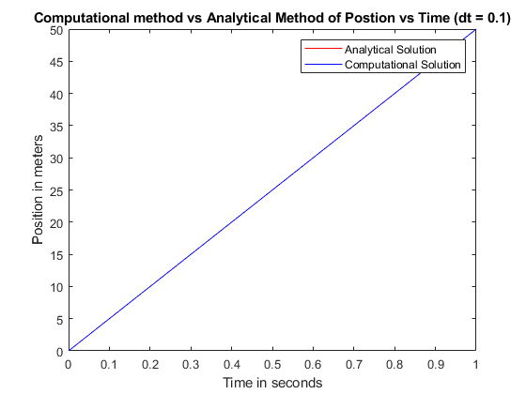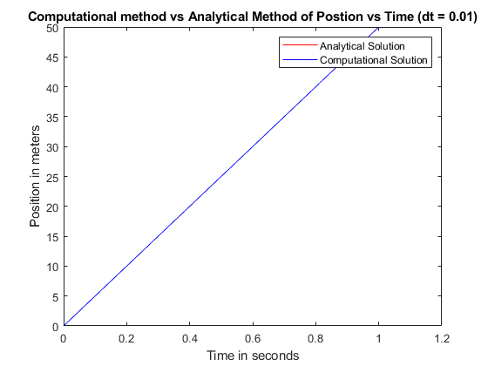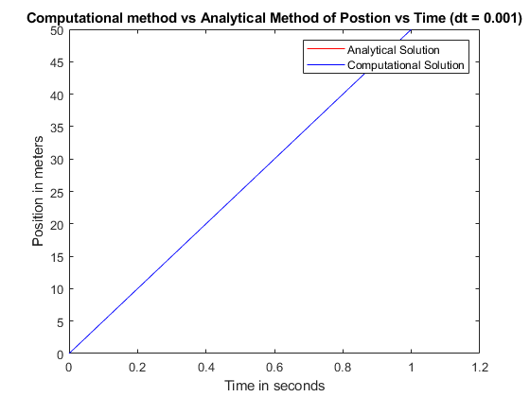

OBSERVATIONS:

As the given model is linear, there is no difference between the analytical and computational model.

QUESTION – 3

(a) Add the effect of atmosphere to problem 1 (still neglecting viscosity and drag). Suppose the falling object is a sphere of radius “r”, computationally study the effect of buoyancy on the motion of the object. Net force needs to be modeled properly (as discussed during lecture); choose proper density of air. Study the effect of “r” and “mass”. You can assume constant “g”.

(b) Also computationally investigate the motion of the same object traveling through a liquid (say water), and compare the motion with the case of air. Use computational data and plots to explain your answer (motion as a function of time).

ASSUMPTIONS:

1. The gravitational force remains constant all heights.
2. Drag force due to atmosphere is absent.
3. Viscosity of the medium has to be neglected.
4. Density of the given body is larger than the density of the medium in which its falling

INITIALIZATIONS:

1. init_height is the height from which the object is released.
2. g is the gravitation due to earth = 9.8m/s2
3. rho_air is the density of air = 1.225 kg/m3
4. rho_water is the density of water = 996 kg/m3
5. mass_ball is the mass of the ball.
6. volume_ball is the volume of the ball

COMPUTATIONAL MODEL:

ANALYTICAL SOLUTION:

RESULTS:

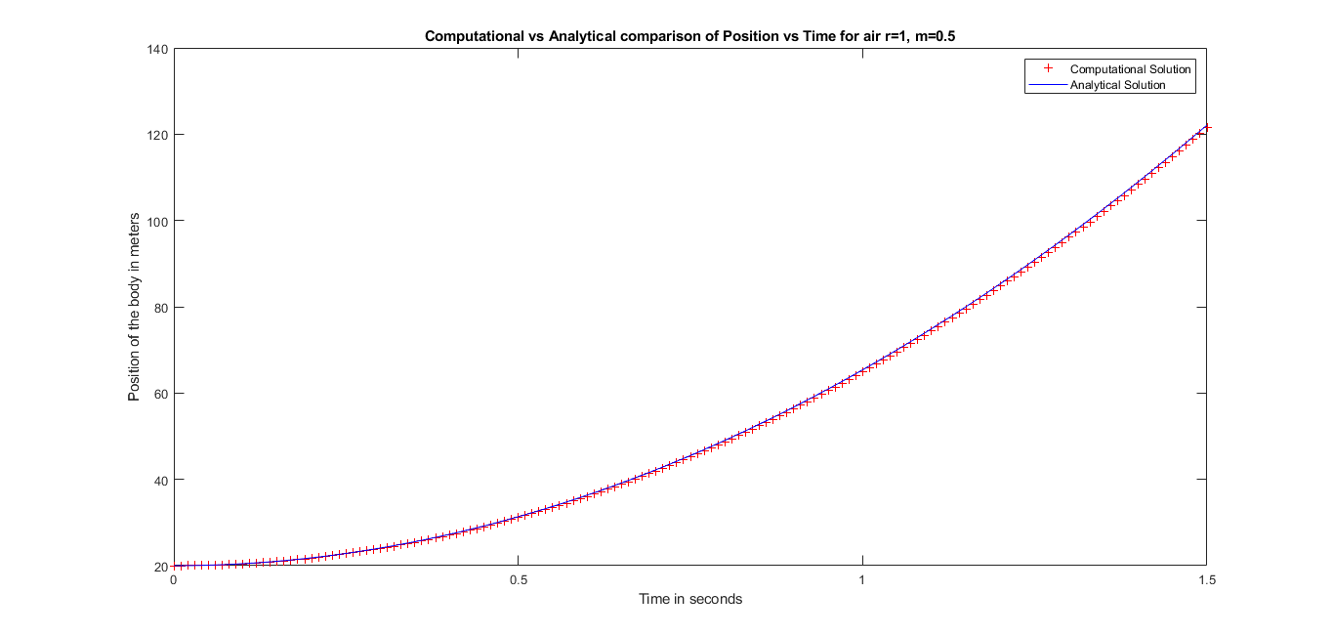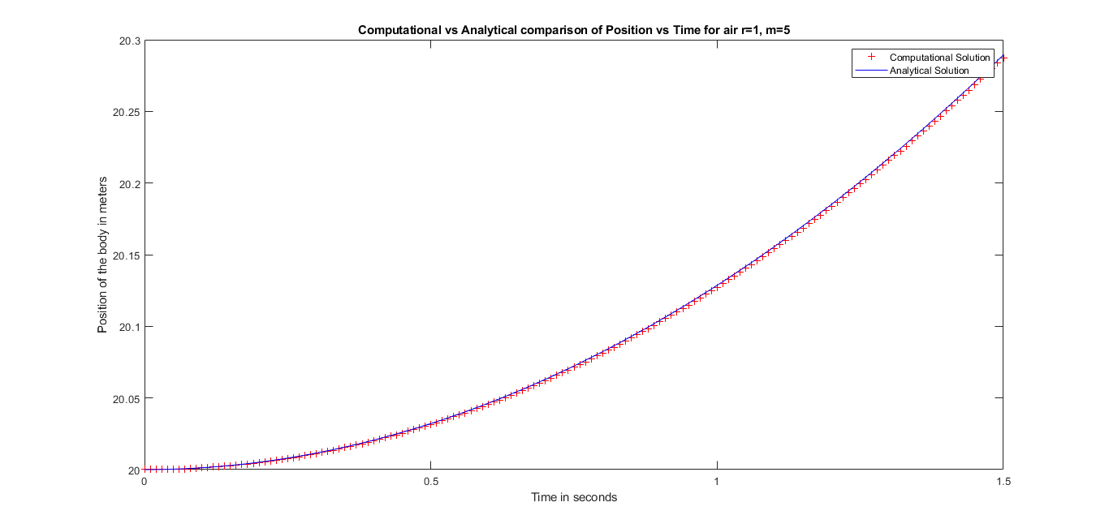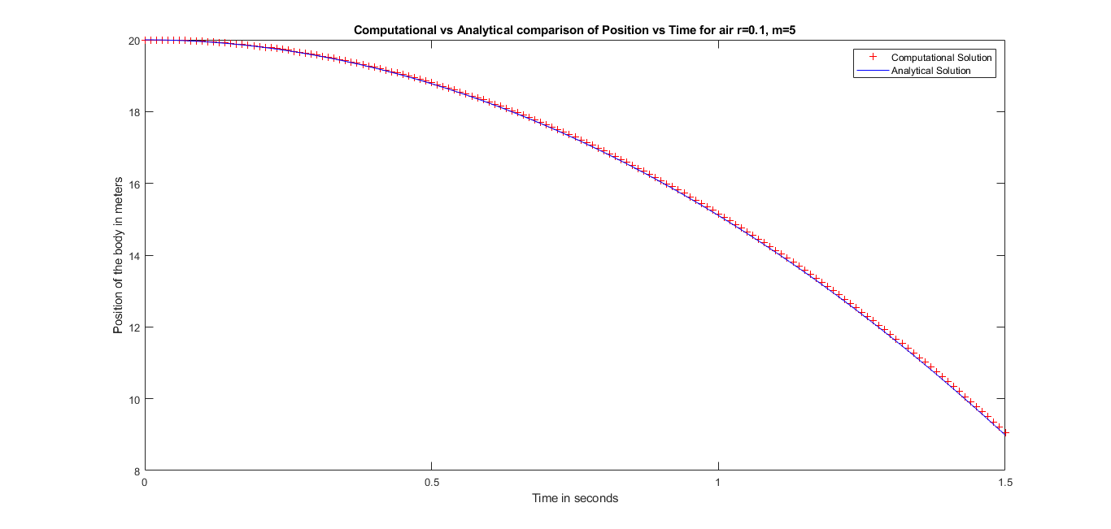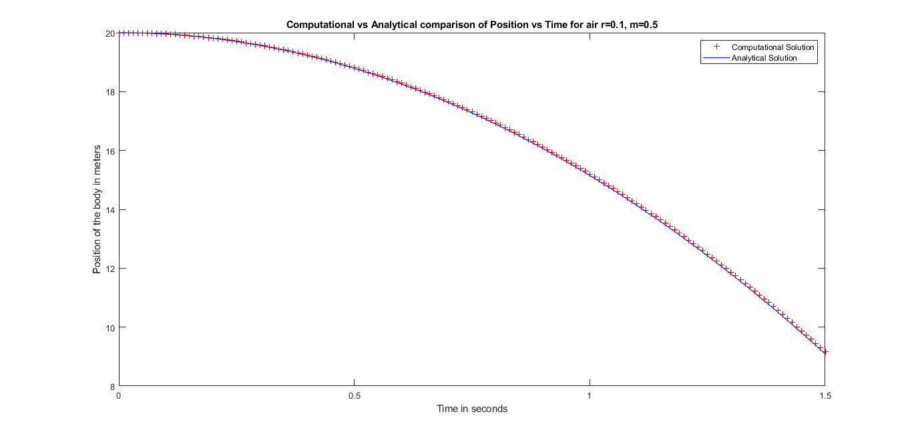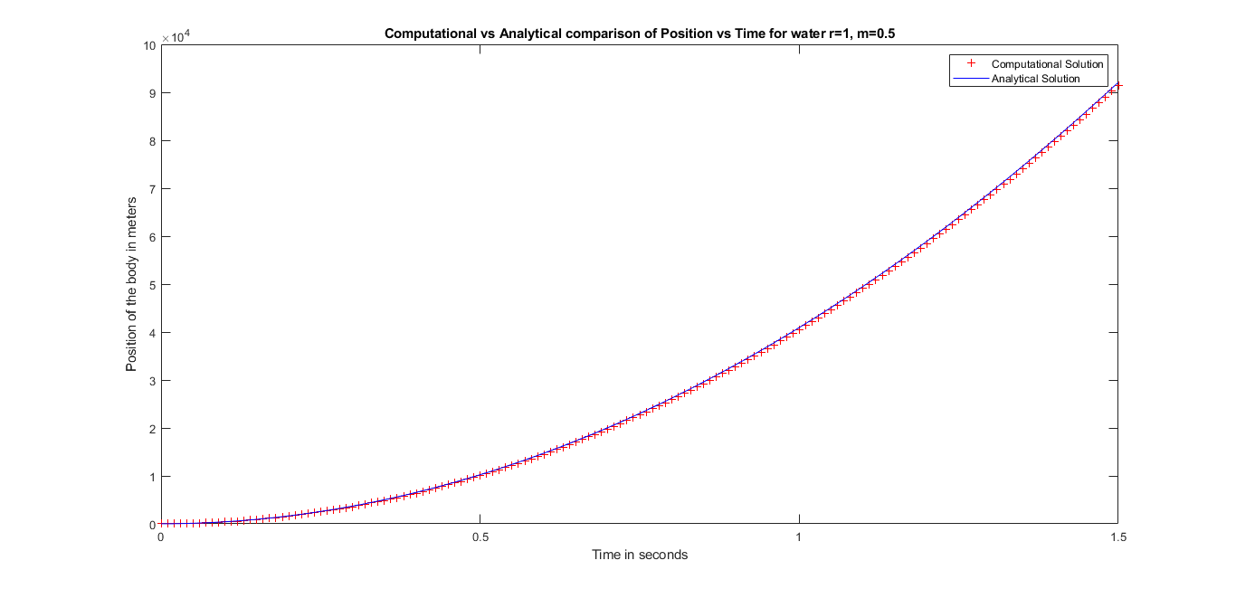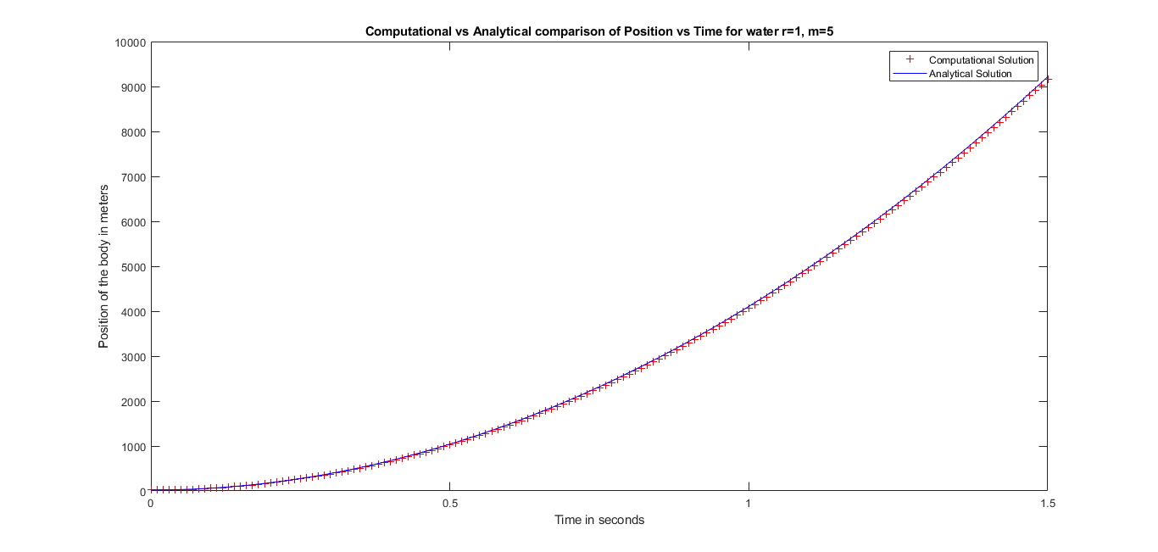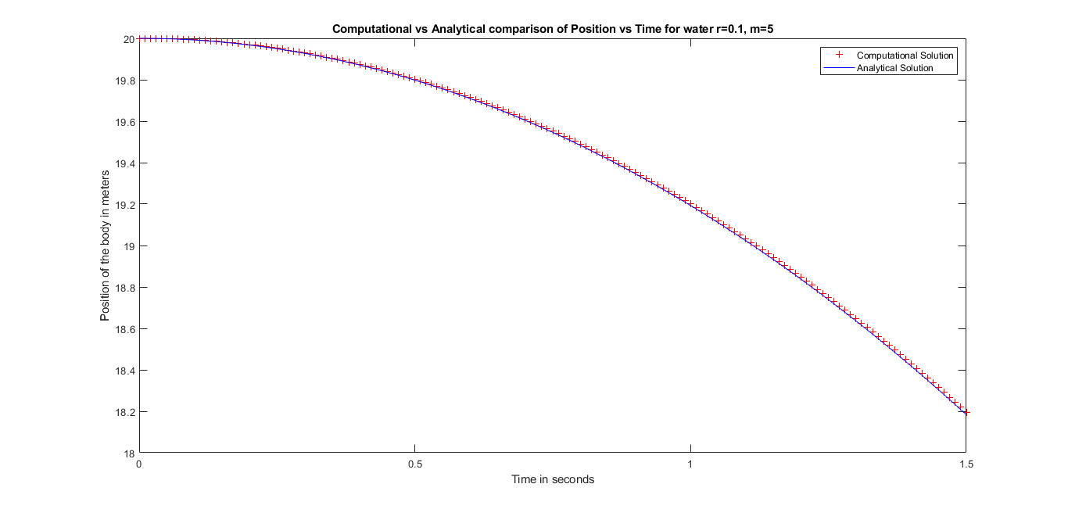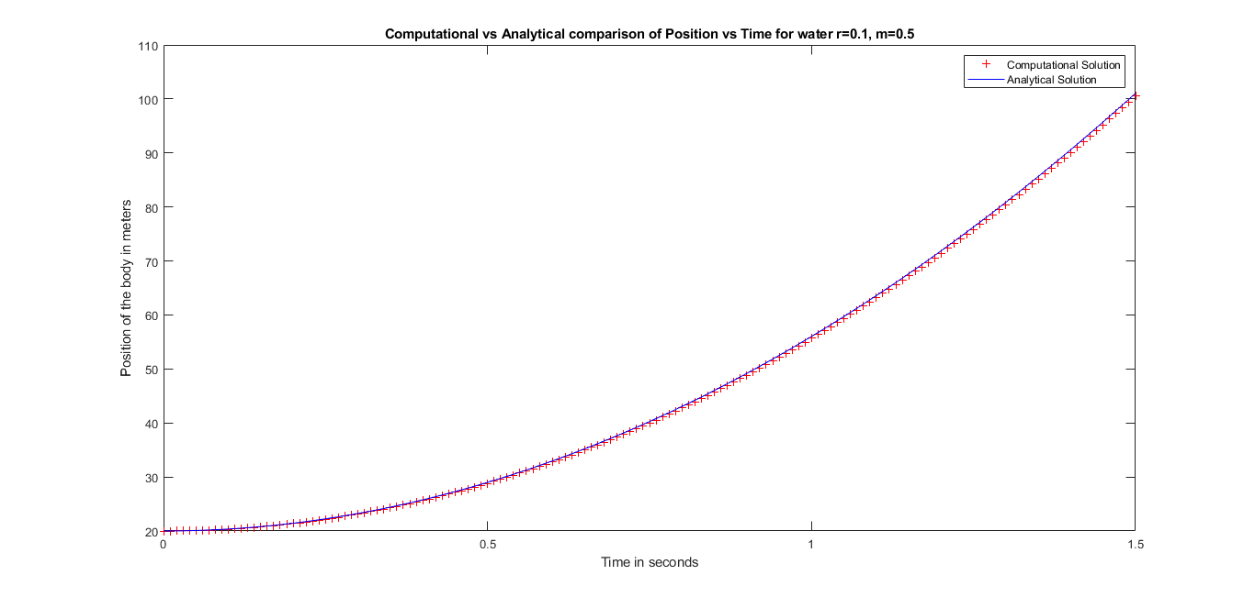

OBSERVATION:

1. If we compare this graph with that in question 1 we will see that in this case the motion continues for a longer time, as the net acceleration in the downward direction is not ’g’ but less than it.(Due to the presence of buoyancy).
2. With increase in the radius of the body, the volume also increases. This implies that the net resultant force acting on the body in the downward direction increases. So, more the radius of the object faster it will reach the ground.
3. As the mass of the object increases the net acceleration acting on the body decreases. Therefore, the net resultant force acting on the body decreases. So, a body with higher mass will take more time to reach the ground as compared to a body with lesser mass.
4. By changing the medium from water to air : The density of water is 816 times more than the density of air, so a much greater buoyant force is applied on the object as compared to that in air.

QUESTION – 4

Now add the effect of viscous drag to the problem 3(b) assuming a small sphere is falling through the liquid with low speed. Model the system using viscous force given by Stokes law as discussed during the class. Choose proper coefficient of viscosity (look at the unit), and analyze the phenomena of terminal velocity.

ASSUMPTIONS:

1. Acceleration due the earth, g, remains constant.
2. The size of the given ball is small

INITIALIZATIONS:

1. height is the height from which the sphere is dropped.
2. g is the gravitational acceleration due to earth = 9.8 m/s2
3. rho_water is the density of water = 1
4. max_t is the time duration for which its to be modelled.
5. r is the radius of the sphere.
6. coeff_viscosity_water is the coefficient of viscosity of water = 8.9*10e-4.
7. Initial velocity v(1) is 0
8. Mass of ball is 1

COMPUTATIONAL MODEL:

ANALYTICAL SOLUTION:

RESULTS:

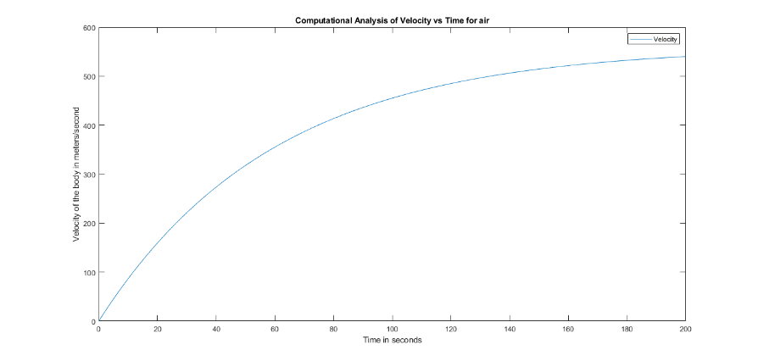

OBSERVATION:

1. We can see that after a certain point the velocity of the object becomes constant as it reaches terminal velocity.
2. Greater the velocity of the body a greater viscous force acts on the body, as the viscous force is directly proportional to velocity.
3. As, acceleration increases, velocity increases and after a point of time, the (viscous force + buoyant force) balances gravitational force.Therefore, a = 0. And the body continues motion with constant velocity within the fluid. This velocity is known as Terminal Velocity.

QUESTION – 5

Modify the program (problem 3) and include the variation of “g” with height. Use the program to computationally investigate the motion of a body dropped from a height of 20 KM (assume constant air density).

How will you use the above program to investigate free fall in a deep mine (by taking proper initial conditions from Google).

ASSUMPTIONS:

1. Gravitational force varies with height
2. The drag force due to atmosphere is neglected
3. Buoyancy is neglected.

INITIALIZATIONS:

1. height from which its dropped
2. g is the gravitational acceleration = 9.8m/s2
3. rad_earth is the radius of earth = 6400km
4. rho_air is the density of air = 1.225 kg/m3
5. rho_water is the density of water = 997 kg/m3.
6. rho_ball is the density of ball = 940 kg/m3 .
7. max_t is the time duration for which the experiment is performed.

COMPUTATIONAL MODEL:

v(i+1) = v(i) + g*(1-2*(x(i)/rad_earth))*dt*(1-rho_air/rho_ball)

x(i+1) = x(i) – v(i)*dt

ANALYTICAL SOLUTION:

RESULTS:

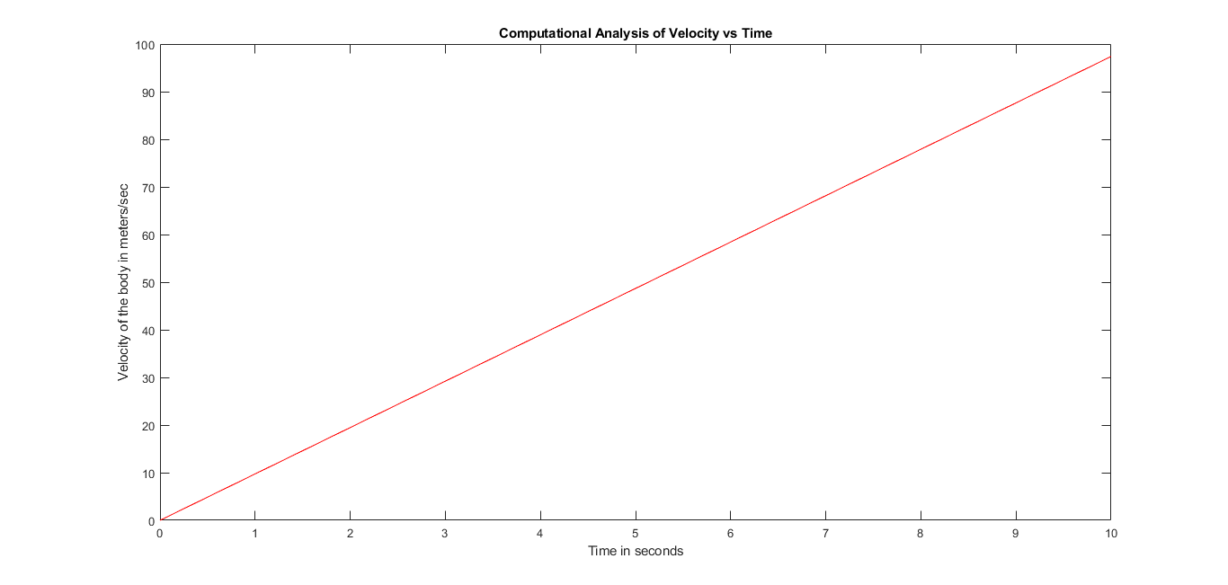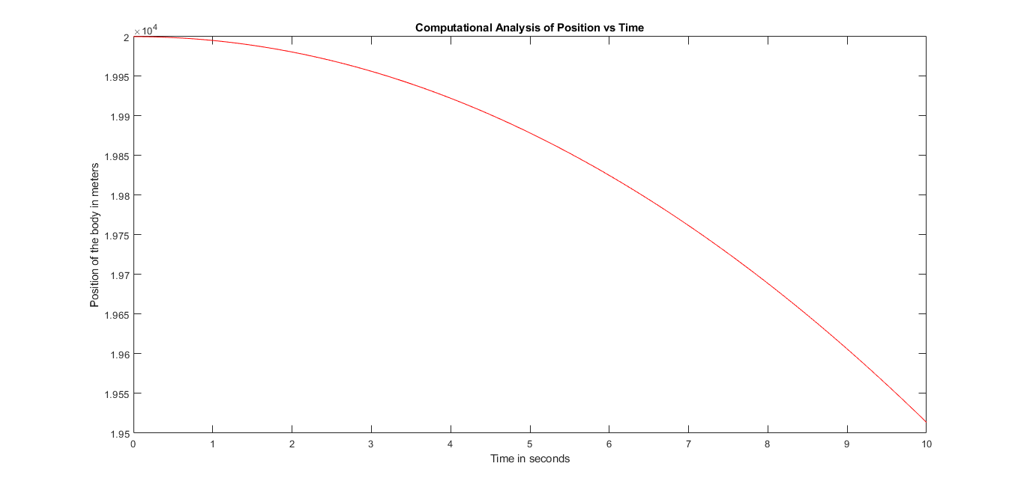

OBSERVATION:

1. Not much change in the displacement and velocity when we take ‘g’ to be varying.
2. This is because for small heights ‘g’ doesn’t change much and can be considered to be constant.

QUESTION – 6

A stone is thrown vertically upwards from the ground with some initial velocity in vacuum (choose a proper realistic velocity). Track the complete motion till it comes down to the ground (computationally). What is the velocity when it strikes the ground, compare with analytical result?

• Compare the result for different values of the time-step

ASSUMPTIONS:

1. Gravitational acceleration remains constant
2. Absence of drag force from atmosphere
3. Buoyancy is neglected

INITIALIZATIONS:

1. g is the acceleration due to gravity
2. max_t is the duration of the experiment
3. u is the velocity with which its thrown.

COMPUTATIONAL MODEL:

1. v(i+1) = v(i) – g*dt
2. x(i+1) = x(i) + v(i)*dt

ANALYTICAL SOLUTION:

x_analytical = u * t – ½ * g * t2

RESULTS:

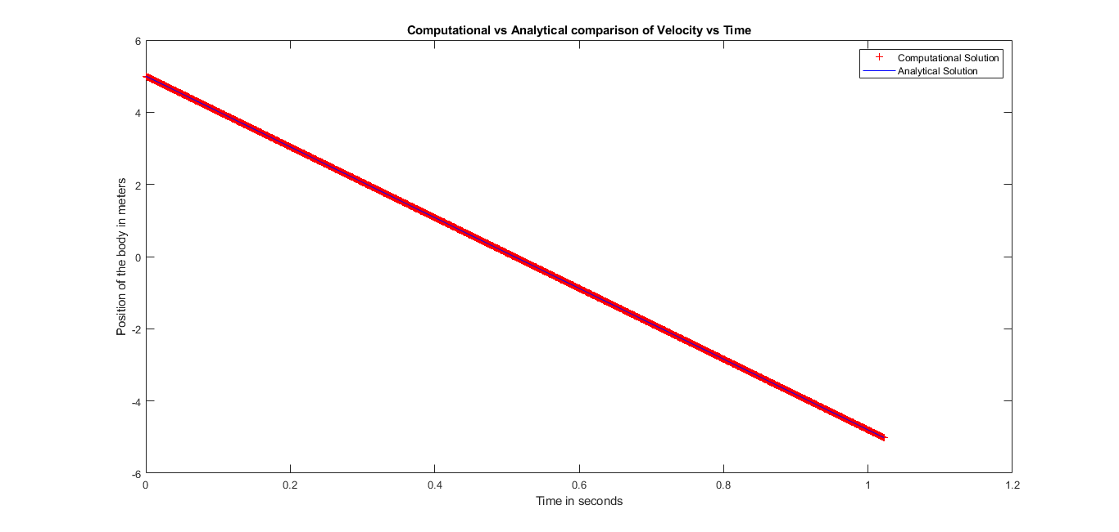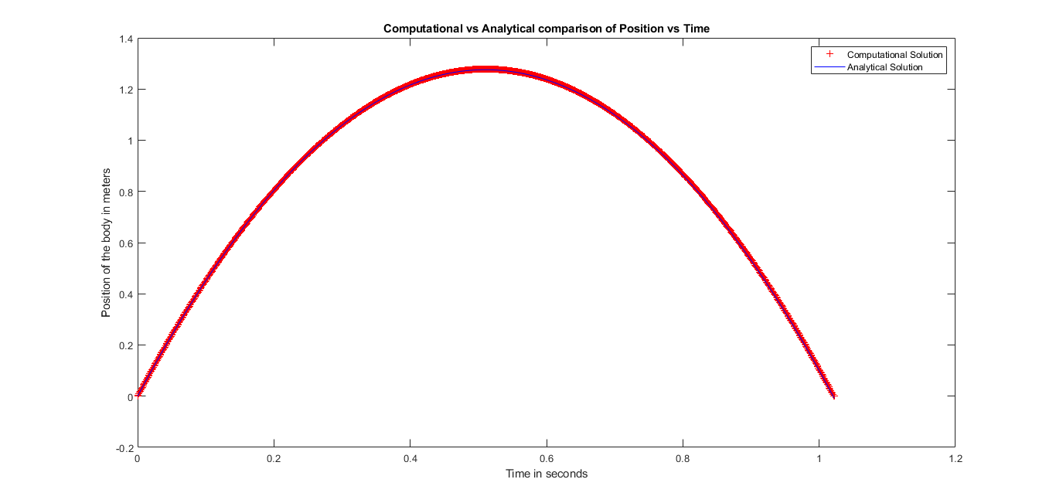

OBSERVATION:

The body after reaching maximum height starts falling like a free falling body. Since the body returns back to the ground the displacement of the body at the end of the motion is zero.

QUESTION – 7

Computationally study the motion of a balloon filled with Helium (use realistic data from Google). Also study the same for 3-4 different gases of your choice. Will the balloon rise up or fall down? Vary the size of the balloon (5 diff size) to study its effect on velocity and distance travelled as a function of time. All conclusions should be based on the plots from your computational data.

ASSUMPTIONS :

1. The acceleration due to gravity g = 9.8m/s2
2. Air drag and viscosity are negligible.

INITIALIZATIONS :

1. g= 9.8m/s2
2. T = end time
3. rho_air = Density of air = 1.225 kg/m2
4. density1, density2, density3, density4 = densities of gases filled in balloon.
5. x = position of body.
6. v = velocity of body.
7. a = net acceleration.

COMPUTATIONAL MODEL :

1. v(i+1) = v(i) - a*dt
2. x(i+1) = x(i) + v(i)*dt

ANALYTICAL MODEL :

RESULTS:

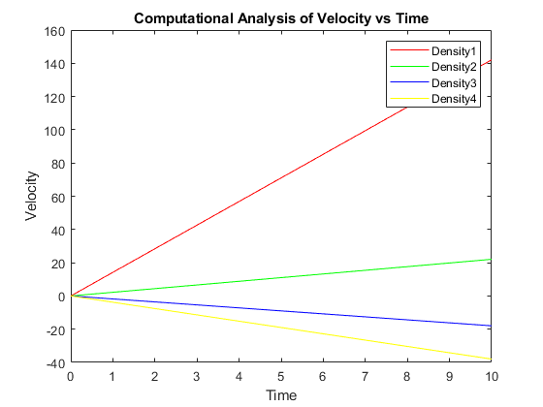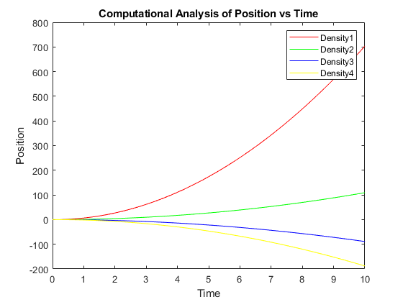

OBSERVATIONS :

1. As the density of helium is less than the density of air, it goes up in the air.

2. The rate of change in velocity is proportional to the density difference of the gas and air. So if the difference is more then it will displace more.

3. From here we can conclude that the balloon filled with a gas with lesser density will go up in air, whereas the balloon filled with higher density gas will go down in air due to the net resultant force acting on it.

4. We can also see that the mass and radius of the balloon have no effect on the resultant force acting on the balloon i.e. they have no effect on the acceleration so there will be no effect of changing the size of the balloon.

QUESTION – 8

Parachute problem: frictional force on the object increases as the objects moves faster (as we learned today in the class). Role of parachute is to produce the frictional force in the form of air drag. Consider the most simple form, so the equation for velocity :

dv/dt = a − bv

where a (from applied force), b (from friction) are constants. Use Euler’s method to solve for “v” as a function of time. Choose a=10 and b=1.

What is the terminal velocity in this case.

ASSUMPTIONS :

1. Gravitation remains constant.
2. Drag force is independent of v as terminal velocity is very less.
3. a = 10 and b = 1 for the parachute under consideration.

INITIALIZATIONS :

1. g= 9.8m/s2
2. h = initial height = 0 m.
3. = velocity of body = 0
4. Equation taken into consideration =

COMPUTATIONAL MODEL :

1. v(i+1) = v(i) - (a - b * v(i)) * dt
2. x(i+1) = x(i) + v(i)*dt

ANALYTICAL MODEL :

1. dv/dt = a − bv
2. On solving equation we get v =
3. From these two we get terminal velocity dv/dt = 0
4. Initial velocity = 0, thus terminal velocity in this case is 10

RESULTS:

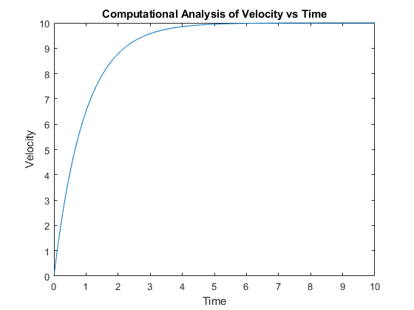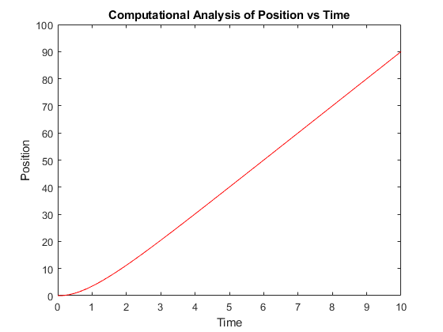

OBSERVATIONS :

1. Analytic terminal velocity = 10 m/s

2. Computational terminal velocity = 10 m/s